Sustead community news
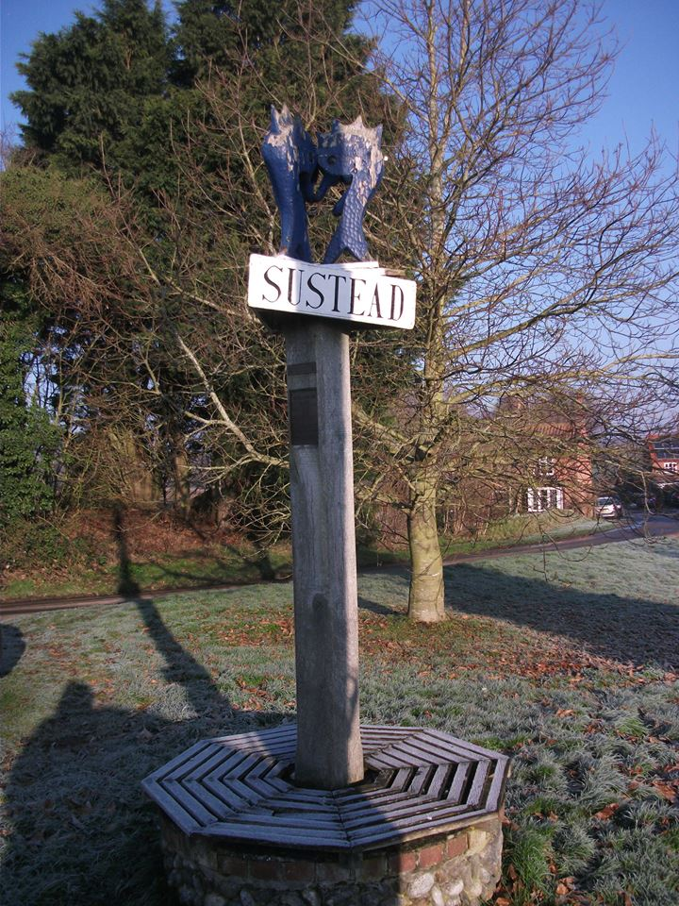
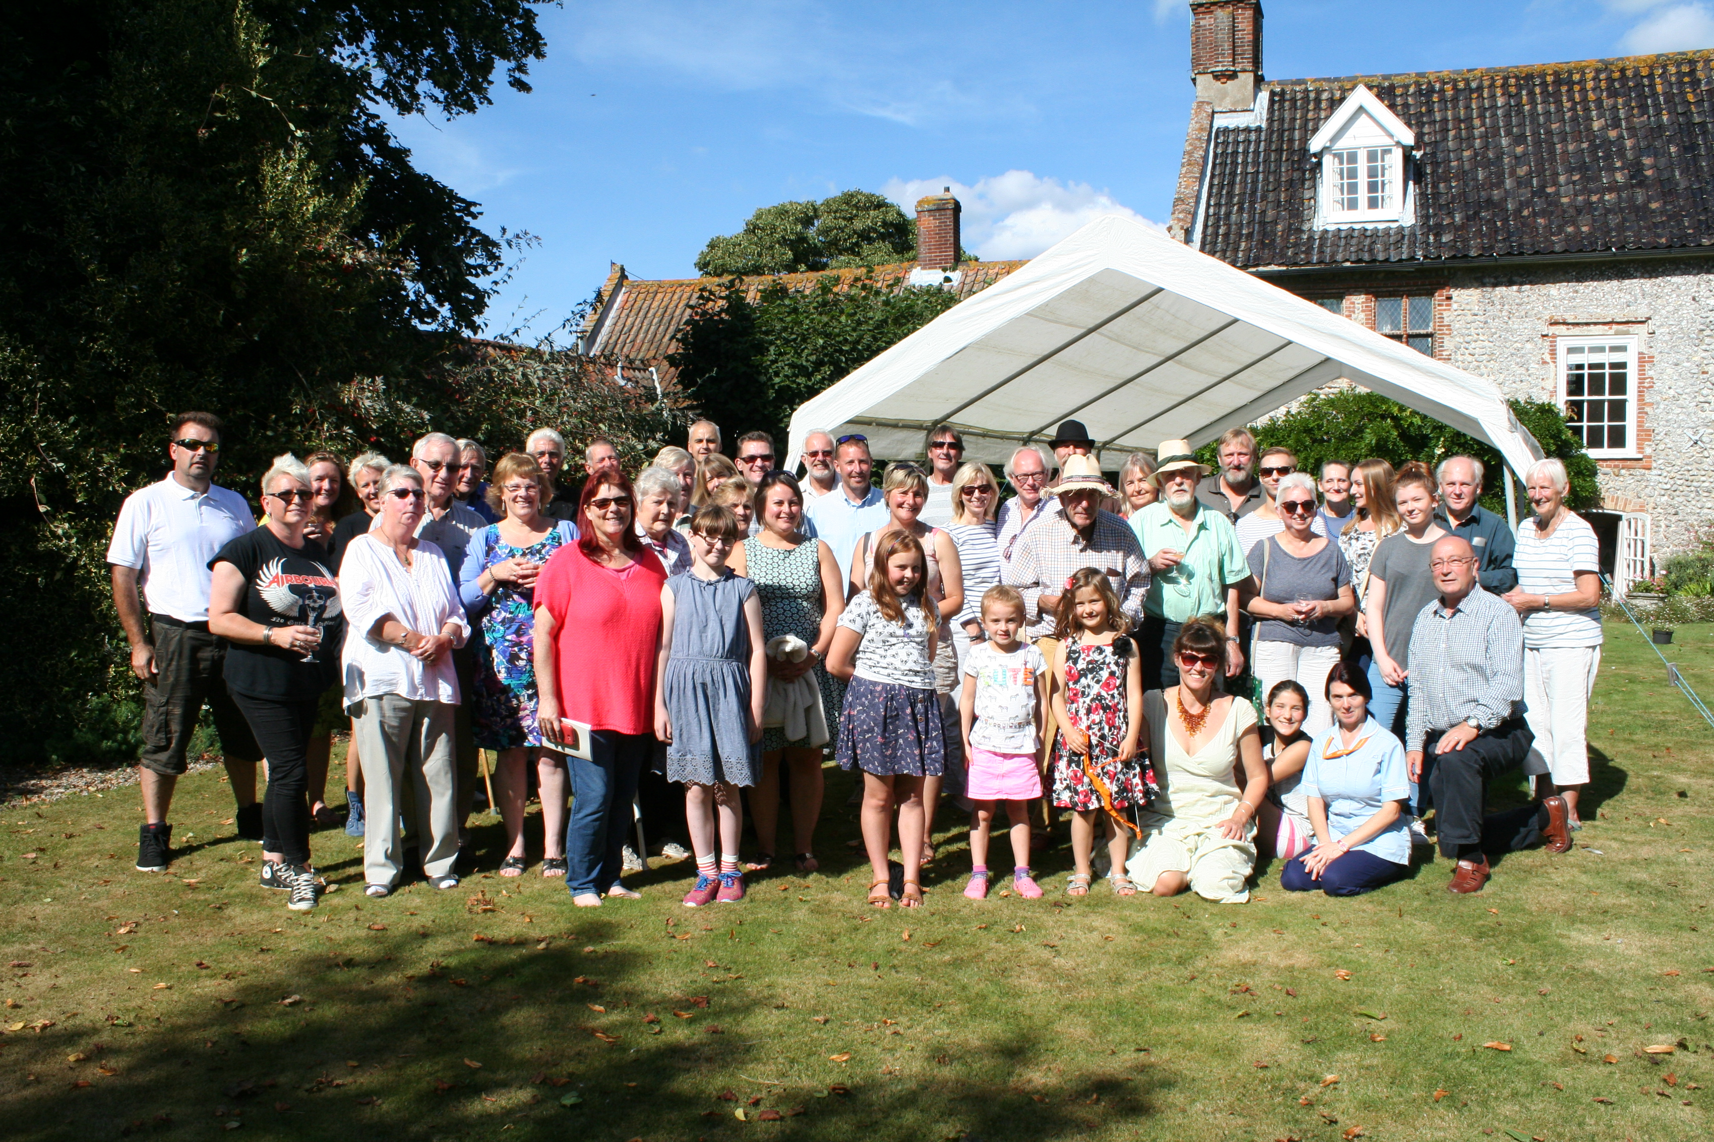
Sustead Millennium Book 2017
A quick reminder to everybody that I’d like to have your contributions to the 2017 updated Millennium Book by Easter – to me, Peter Maingay, by email (petmai6@hotmail.com) or delivered by hand to Field Cottage, 51, The Street, Sustead. You choose how much you write and what you write, but perhaps be guided by what people wrote in the original book. As I said before, if you have lost your copy of the book, or never had one, let me know and I’ll bring one round for you.
Sustead Church appeal for the repair of the chancel roof
The church architect in his quinquennial report has advised that the chancel roof needs urgent repair to preserve the unique painted ceiling.
Tenders are out but builders are all very busy and we are unlikely to be able to start the work yet. When applying for grants we need to say what support we have from the community, so we are pleased to hear that proceeds from the Millennium Book 2017 (combined with the Sustead Recipe Book) will go towards the chancel roof repairs. But, as we have thousands of pounds to raise, any contributions or ideas for raising money would be greatly appreciated! When we get a firm quote for the repairs, we can give more detail.
Email addresses
It would help enormously to have everybody’s email addresses so that we can send newsletters by email rather than delivering them by hand – but the latter is always possible if you prefer, or if you don’t use email. Could you please let Peter know your email address so that he has as complete a list as possible? If you receive your newsletter by email then, where links are given, you would only have to click on them to access the information.
Sustead, Bessingham and Metton Parish Council
If you are interested in the Parish Council and what goes on at their meetings (which, incidentally, you can attend), go to their website at http://susteadpc.norfolkparishes.gov.uk/ The website has been brought up to date - thanks to Kirsty Cotgrove, the parish clerk, for getting that done. Along with the Sustead (unofficial) Facebook page (22 Members so far - why not join?) which John Toye has started, it is a good way to keep in touch with – and to get involved with – village and parish matters.
Upcoming events for Sustead
Here are a few events being organised in the village this year. If you know of any more that might be of interest to people please let us know and we will include it in future newsletters.
Wed 26th April.
Kim’s Norfolk Kitchen is having a coffee morning from 10.30 to 13.30 in aid of the Benjamin foundation (http://benjaminfoundation.co.uk/what-we-do)
Sat 3rd June.
The annual Sustead coffee morning will be held at Sustead Old Hall on Saturday 3rd June, between 10.00 and 12.00. Proceeds go towards the church upkeep. This is a really good event but get there early if you want to have any chance of buying cakes!

Sunday 10th September
After last year’s wonderful village get together at Sustead Old Hall it was felt that this could be a good thing to do annually. This year, with the Felbeck Trust (http://www.felbecktrust.org.uk/) having done such a grand job on the common, we thought that we could hold an event there. We have checked with the trust and they say that this is a good time of year to hold an event there with regard to nature and habitat cycles.
As last year, it would be good if as many people as possible could prepare food, drink, games for children etc as a collective effort. John Toye is happy to coordinate the effort but please let him know what areas you would like to help in (johntoye56@gmail.com). If we all do a little no one needs to do a lot. John has a pop up 3mtr by 3mtr gazebo we can use along with a big enough gas BBQ if we want hot food. It’s your event so let John know what you would like.
Do you have a passion for something?
If you have a passion for something and you would like to write an article for the newsletter then send it in. Maybe you are a keen gardener and can give us some tips on what to do at the time of year you are writing; maybe you are a keen motorist and can give us tips on looking after your vehicle and preparation for the longer journeys of summer; maybe you are a keen environmentalist and can give us some simple practical tips we can use or even write about a place you have visited or an event you have attended. All that is asked is that you keep it light and friendly, entertaining and maybe even humorous.
Where has all the water gone?
You will have noticed that the water has now gone from near the village sign and but it is now accumulating by the common. It turns out that there is a further pipe to unblock under the road and we are sure that that will be sorted before long. Interestingly, during the events around the flooding, it was learnt from someone in the village that there is an underground stream that runs from near the ‘hill’ to the west of the village green to the centre of the village. Have you got any unusual snippets of info about the village? Pass them on and we can share them.
Village Green
Some people have expressed an interest in tidying up the village green. Simon Empson (Rose Cottage) has agreed to help with the village sign refurbishment (thank you, Simon), so if it disappears we know where it’s gone. Additionally some feel that it would be good to tidy up the green area generally including perhaps some reinforcement where people park and wait for busses to help the grass survive the winter months and to provide a new or refurbished bench. If you agree and have got some ideas please let us know and if you would like to volunteer your manpower, money, time etc again please let us know. It’s our village so let’s own it and care for it.
New news hounds
Peter Maingay and John Toye have been busying themselves with finding out and sharing this information. They have been joined by James Appleby and Chris Carey so there are more people to give your stories and information to.

